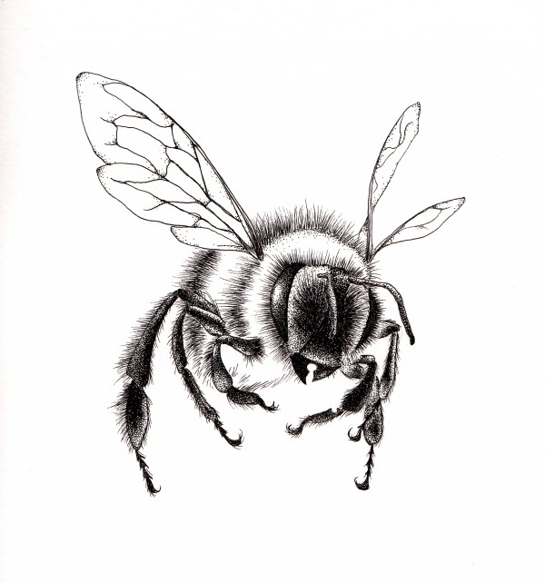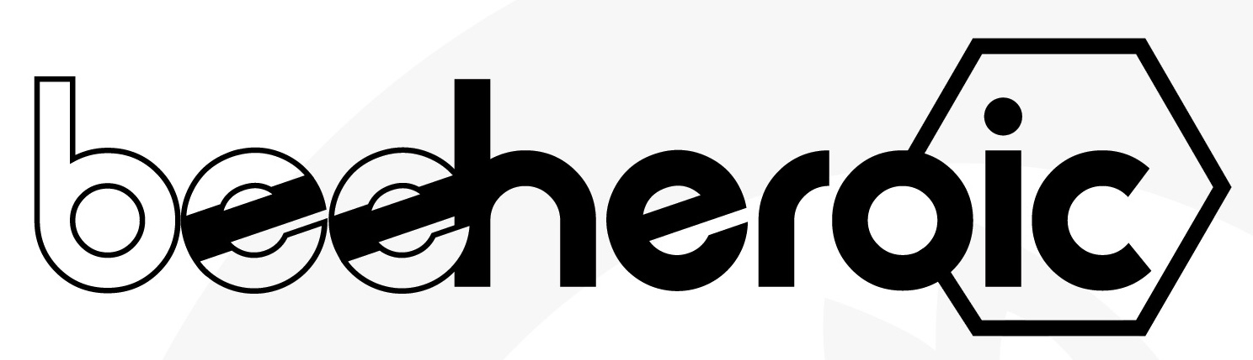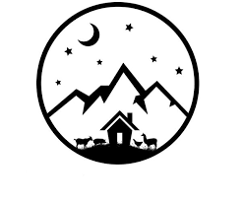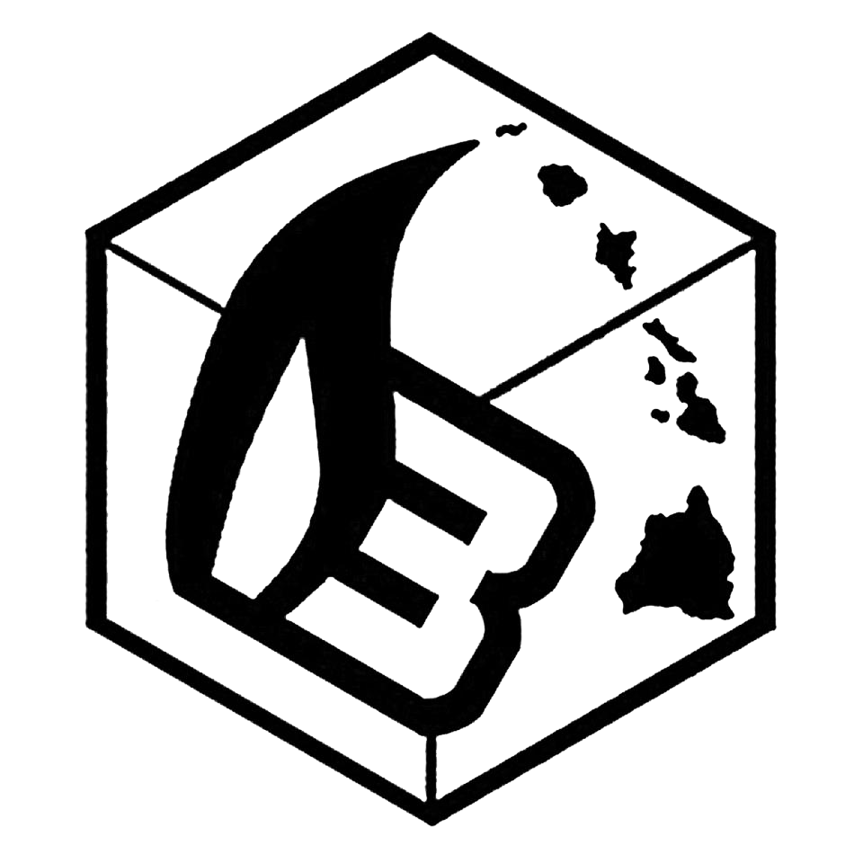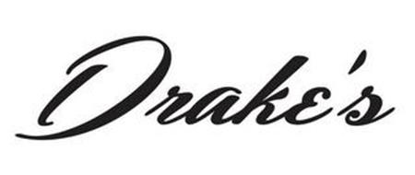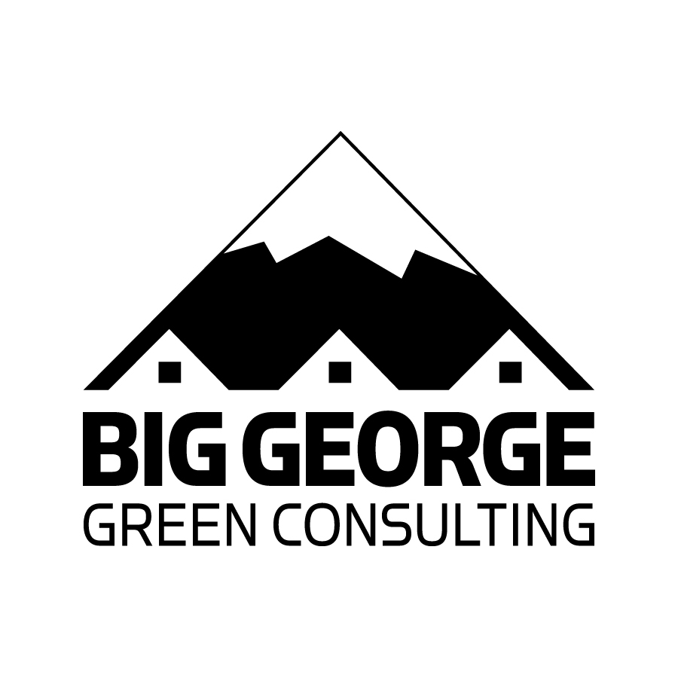

**Buds and Bees** @ Venus Moon Ranch

6.7.18 12- 6pm

**Buds and Bees includes:**

* Presentations on pollinators, hemp, and climate
* Hemp and eco booths
* Hemp-huggin’ give aways
* Organic brews ~ Drake’s bee-huggin’ spirits!
* and more!

https://www.beeheroic.com/buzz-events

https://www.facebook.com/Bee.Heroic.Now/

**Join Bee Heroic and Venus Moon Ranch during Hemp History Week** for an afternoon of bee-lovin’, hemp-huggin’ goodness!

**Venus Moon Ranch**

4932 County Road 119

Hesperus CO 81326

**June 7, 2018**

12:00 pm - 6:00 pm

For info: [beeheroic@gmail.com](mailto:beeheroic@gmail.com), or [info@venusmoonranch.com](mailto:info@venusmoonranch.com)